Capstone Project: Full SOC Workflow Simulation Report
Objective
The objective of this capstone project was to simulate a complete Security Operations Center (SOC) workflow, including attack detection, alert triage, incident response, containment, escalation, and reporting. The exercise combined concepts learned throughout the assignment to demonstrate a realistic end-to-end incident handling process.
Tools Used
- Metasploit
- Metasploitable2
- Wazuh
- CrowdSec
- TheHive
- Microsoft Word
- Microsoft Excel
Introduction
Modern Security Operations Centers must continuously monitor systems for malicious activity and respond quickly to potential threats. Effective incident response requires multiple stages including detection, investigation, containment, escalation, documentation, and communication.
This capstone project simulated a cyberattack against a vulnerable server and demonstrated how SOC analysts can identify and respond to the incident using standard security tools and workflows.
Attack Simulation
A controlled attack was simulated using Metasploit against a vulnerable Metasploitable2 system.
Attack Scenario
The attacker attempted to exploit a Samba service vulnerability using a known exploitation technique. The objective was to simulate unauthorized access and trigger security monitoring systems.
Attack Details
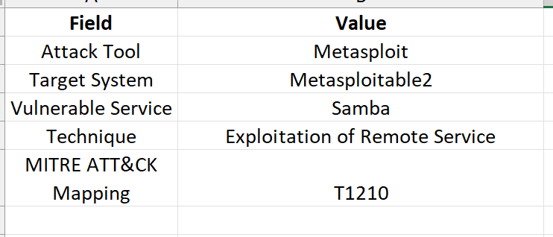
The attack successfully generated security events required for the remainder of the investigation workflow.
Detection and Monitoring
Wazuh was configured to monitor activity and generate alerts when suspicious events were detected.
Detection Log
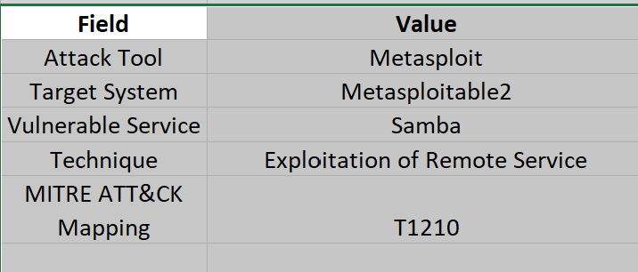
The alerts provided early warning of malicious activity and initiated the SOC investigation process.
Alert Triage
The generated alerts were reviewed by a Tier 1 SOC analyst.
Triage Activities
- Verified alert legitimacy.
- Reviewed source IP address.
- Examined associated network activity.
- Assessed severity and potential impact.
- Determined escalation requirements.
Triage Outcome
The incident was classified as High Priority due to the attempted exploitation of a vulnerable service and the possibility of unauthorized access.
Incident Response and Containment
Following triage, immediate containment measures were implemented to reduce risk.
Containment Actions
- Isolated the affected virtual machine.
- Blocked the attacker IP address using CrowdSec.
- Preserved relevant system logs.
- Prevented further communication with the source IP.

Verification
A network connectivity test confirmed that communication from the attacker system was successfully blocked after containment measures were applied.
Incident Escalation
Due to the severity of the incident, the case was escalated to Tier 2 analysts using TheHive.
Escalation Summary
The incident involved a suspected exploitation attempt targeting a Samba service on a vulnerable server. Initial investigation confirmed malicious activity originating from IP address 192.168.1.101.
Containment measures were applied immediately, and the source IP address was blocked. The incident was escalated for deeper forensic investigation and impact assessment.
Escalation Status
High Priority – Escalated to Tier 2
Timeline of Events
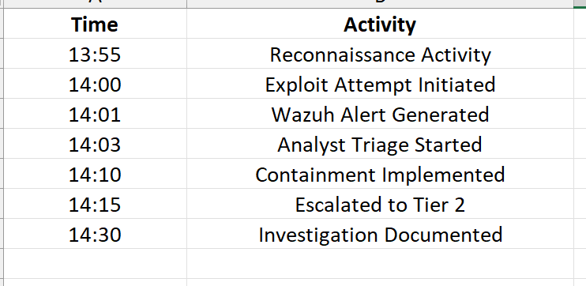
The timeline illustrates the complete incident lifecycle from detection to escalation.
Findings
The investigation identified multiple indicators of malicious activity associated with the attack.
Key Findings
- Exploitation attempt against Samba service detected.
- Unauthorized access attempts observed.
- Suspicious outbound communications identified.
- Security controls successfully generated alerts.
- Containment actions prevented further activity.
The monitoring and response workflow functioned as expected throughout the exercise.
Recommendations
Based on the investigation, the following recommendations are provided:
- Regularly patch vulnerable services and operating systems.
- Maintain continuous monitoring using SIEM solutions.
- Review firewall and access control configurations.
- Conduct periodic vulnerability assessments.
- Improve detection rules for exploitation attempts.
- Perform routine incident response exercises.
These recommendations will help strengthen organizational security posture and reduce future risk.
Executive Summary
A simulated cyberattack targeting a Samba service was successfully detected and contained within the SOC environment. Security monitoring tools generated alerts that enabled analysts to investigate and respond rapidly.
The attacker’s activity was identified, blocked, and escalated according to standard incident response procedures. No evidence of significant impact was observed during the exercise.
The project demonstrated the effectiveness of monitoring, detection, containment, escalation, and reporting processes within a Security Operations Center.
Conclusion
This capstone project successfully demonstrated a complete SOC workflow, beginning with attack simulation and ending with incident reporting. Throughout the exercise, analysts performed detection, triage, containment, escalation, and documentation activities using industry-standard tools and methodologies.
The project highlighted the importance of coordinated incident response and demonstrated how SOC teams can effectively manage cybersecurity incidents. All objectives were achieved, and the simulated attack was successfully detected and contained.

